Relevant Fuel Solutions Filtration System (Containerized Mobile Unit):
The gas turbine market has met with many changes over the past decades with dramatic changes in the need to quickly mobilize power plants, especially in times of emergency. Nearly all major turbine suppliers have some forms of mobile power for this purpose. What many times accompanies the emergency situations is a loss of fuel sources other than liquid fuels such as diesel fuel. Diesel fuel is generally available worldwide through trucked, barged, or shipped means. Recent storm related events in such areas of the world like Puerto Rico have seen major distributors of fuel air shipping tankers to move fuel from ships and barges to needed points of power.
Regrettably, every time fuel is handled, the integrity of the fuel in terms of its original cleanliness is compromised. Barged and shipped fuels are most susceptible. The introduction of water and sea water in fuel holding tanks adds to biological contaminants and cross contamination from other fuels that might have been transported in the same tanks. The points of entry are too numerous to quantity. What once was refinery level fuel typically produced to an ISO 4406 class of 18/16/13, and recognized as the Global WW Fuel Charter Definition of Clean Fuel, can easily be compromised to ISO grades 5 to 7 times higher. So what does this mean?
ISO 4406 is a world recognized standard to measure particulate levels in fuel and other liquids. The classification breaks the fuel into particle sizes of greater than 4 micron, 6 micron, and 14 micron particles. ISO4406:1999 Codes provides a range code for the predicted number of particles per milliliter in a range code. For example, see the following range codes:
18= 1300 to 2500 (>4 um)
16= 320 to 640 (>6 um)
13 = 40 to 80 (> 14um)
If fuel around the world, was supplied to this standard in all cases, bringing fuel to cleanliness levels needed for today’s Tier 4 engines and for gas turbine use would not be as ominous a task even when considering that the fuel for these sophisticated engines might need a fuel cleanliness of 12/10/7 (20 to 40, 5 to 10, and 0.64 to 1.3 particles)
But this is hardly the case when looking at fuels worldwide and preparing for the mobilization mentioned earlier in this paper. It is not uncommon, at all, to see fuels in some countries where transport systems are unsophisticated or simply subject to the numerous contamination points mentioned previously to have ISO4406 codes of 24/20/12 or 22/20/18. When looking at these fuels in comparison to the above referenced example, please compare:
24= 80000 to 160000 (> 4 um)
20 = 5000 to 10000 (> 6 um)
12= 20 to 40 (> 14 um)

The often repeated practices of purification of fuels when supplied in the 18/16/13 class that are now subjected to the 24/20/12 fuel class are just not suitable to handle the significant increased dirt load. Cases can be cited where such short sighted looks at fuel have caused an inability to start the equipment, inability to run the equipment reliably and continuously, increased engine maintenance, increase filter element change outs, and most importantly loss of confidence by the ultimate customer in the supplier of the power equipment. A simple recommendation is “know your fuel” and absolutely do not consider that all diesel fuel is the same. The customer experience moving to commercial acceptance will be greatly enhanced by attending to this issue in advance.
However, there are times where speed of supply does not allow for fuel testing and therefore, a preparation for what the industry would consider “bad fuel” or “worst case” fuel needs to be built into the purification designs. Generally, this does not favor a conventional particulate removal approach through filter elements only. Let’s understand why.
A gas turbine running 75 GPM of No. 2 diesel at 4000 hours per year will see 18,000,000 gallons per year of fuel. If the fuel entering meets with an ISO Class of 24/20/12, and the fuel at the gas turbine nozzle needs to meet with a 12/10/7 class fuel, this translates to a dirt removal of 2996 pounds (1,357,398 grams) per year. Real applications like this must employ a number of purification devices in addition to a total discipline of fuel unloading techniques, particle straining, proper tankage, and even particle monitoring at the unloading point. Again, I mention, that this all has to be accomplished in days upon mobilization and not weeks and months as before.
So what kind of equipment is available for this formidable task? What is going to take the bulk of the removal process? The industry has opted to consider centrifuges many times, more from the repeated practices perspective of years past rather than from considering other more cost effective, more reliable, and more serviceable perspectives. Centrifuges generally have a high initial capital cost and like many forms of equipment that have high speed moving parts are subject to increased maintenance. When considering that this piece of equipment might be hundreds or thousands of miles from the nearest service center, this is not the best approach. Further centrifuges tend to have very tight particle size cut off depending on the G force developed based upon the diameter of the bowl and the rotational RPM. This many times causes a high percentage of fines to pass through which result in a non-uniform loading condition of downstream equipment shortening mean time between change out of the downstream equipment.
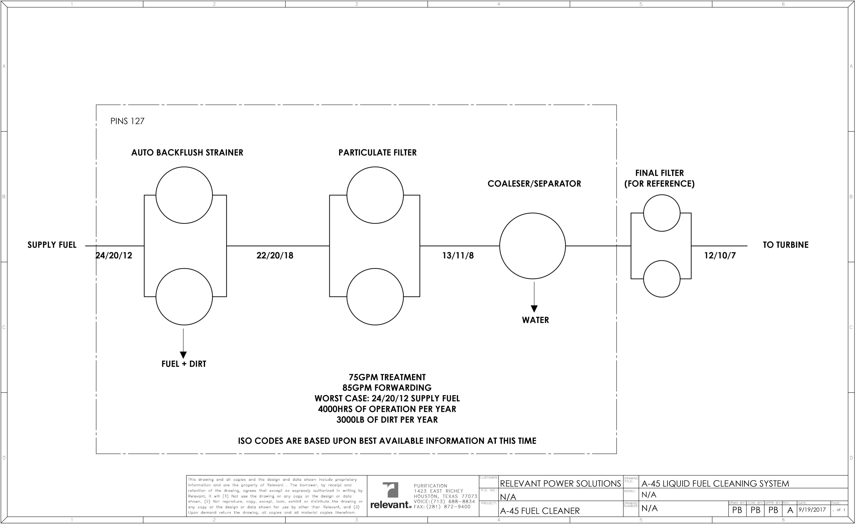

A very suitable alternative to the centrifuge approach is the use of an automatic backflush design as the primary dirt removal device. The automatic backflush filter inherently creates a much more uniform size distribution of solids which produces a “caking” effect on the downstream filters. The automatic backflush filter has less moving parts that operate that actuate the mechanism to alternate between filtration chambers. This happens approximately once per hour or as needed. This cycle is field adjustable by the control panel allowing for adjustments to be made relative to the dirt loading. If for example, the fuel is much cleaner than expected, the cycle to backflush can be extended by the control mechanism thus saving fuel. The control panel allows for the cycle to flush period on a time basis or on a differential pressure basis. The performance of this filter can be expected to reduce the ISO count of the incoming fluid by approximately two (2) ISO counts. Referring back to the operation example discussed herein, a reduction of two (2) ISO counts (24/20/12 to 22/20/18) would translate to a reduction in the dirt load by approximately 1953 pounds (884,520 grams) per year. The downstream filtration equipment is charged then with moving the ISO counts to the gas turbine nozzle specifications. In the example cited, the automatic backflush filter contributes approximately 65% of the dirt removal. When containerized, a small hoist placed directly above the motor assembly is all that is needed to perform removal of the actuation shaft if it ever becomes necessary. A final advantage of the automatic backflush approach is linked to the filtration elements (candles) that are employed. If it becomes desirable to optimize a site condition, the candles can simply be removed and changed to an alternate micron size providing yet another advantage compared to the centrifuge approach. The candles supplied as part of our standard container system are 3 micron nominal / 6 micron absolute.
As the fuel leaves the automatic backflush filter, the more conventional approaches are applied in series. The first step is a further particle reduction in twin particulate filters rated for 2 micron absolute. In the containerized approach, these filters are in parallel allowing for a shorter filter element design easing the process of removal and shortening the maintenance cycle. The particulate filters are sized to individually handle the full flow during the outage of the parallel filter during filter element change out. With the bulk of the dirt removed in the auto backflush filter, the particulate filters move the fuel ISO count into the approximate 13/11/8 range providing “clean fuel” to the coalescer/separator downstream.
Downstream of the particulate filters, a final polishing of the fuel prior to the clean fuel storage tanks is accomplished by removing trace particle amounts and coalescing water that might be entrained in the fuel. In the containerized approach, this is a single vessel housing four (4) coalescing elements and three (3) separator elements. Water is separated in this filter and disposed prior to sending the fuel to the clean fuel storage tanks. Typical performance of this filtration section produces fuel in a range of less than 50 ppm water.
Up to this point, this report does not address water that might be present in the fuel. Certainly, this is not desirable for many reasons, most significantly as it relates to forming contamination layers in tank storage. While mechanical means of removing entrained water has been discussed, water must be dealt with in the early supply phase and in storage because diesel fuel continues to take in moisture even after mechanical removal through venting of the storage tanks. Enzyme based additives such as Blue42 ™ should be dosed at a rate of 5 gallons per 20000 gallons of supplied fuel. The Blue42 enzyme in no way affects the chemistry of the fuel, but acts to keep water dispersed in the fuel when in an agitated format and works to minimize the formation of contamination layers while fuel is idle in storage. Blue42 cannot be overdosed which simplifies manual dosing and is available in multiple size bulk containers for direct injection. Water that remains dispersed in the fuel can be burned off as water vapor. Blue42 fuel and tank cleaner has many additional benefits to include, but not be limited to, prevention of fuel oxidation, improved combustion for improved starting, increase in fuel economy, and reduction of emissions. All of these details are discussed further at Blue42fuel.com. A reduction in the contamination layer has many, many advantages, but in the context of the discussion of this paper, reduces the formation of sludge and bacteria formations that must be removed in the final chance filters should this matter become dispersed in the final draw of fuel before the engine. In short, the additive supports the work that has been done by the containerized fuel filtration system thus preventing rework of the already clean fuel.
Critical in the overall fuel forwarding process is to draw the clean fuel moving to the final last chance filters from above the contamination layer that might exist. This can be accomplished by drawing the fuel from the top of the tank to a specific down comer level or from a low point on the clean fuel supply tanks at a minimum of 10” from the tank base assuming that this point is above any contamination layer that might exist.
Fuel moving from the clean fuel supply tanks must be filtered a final time prior to the engine. This “last chance” filter supplied as 2 micron absolute is conventional in approach and will only need to be changed at the system specified differential pressure.
When taking into account all of the fuel purification actions discussed herein, fuel success can be achieved in even the most undesirable of situations. Success is startup, continuity of run, and reduction in fuel related maintenance. Success is also defined here in the ability to engage the purification process with the simplest of integration and in the shortest time cycle.
Always remember, Clean Engines Run Best on Clean Diesel (copyright Relevant Fuel Solutions).

Author: Russell A Braden, President, Relevant Fuel Solutions, Houston, Texas 713-688-8834
This article is copyrighted by Relevant Fuel Solutions. Reproduction or use without the consent of Relevant Fuel Solutions is strictly prohibited.

